WORK IN CANADA GUIDE
DIETITIANS AND NUTRITIONISTS
NOC 3132

Presented by:
WORK IN CANADA NOW consulting AND placement

DIETITIANS AND NUTRITIONISTS

NOC 3132

In CANADA:
Dietitians and nutritionists plan, implement and oversee nutrition and food service programs. They are employed in a variety of settings including hospitals, home health-care agencies and extended care facilities, community health centres, the food and beverage industry, the pharmaceutical industry, educational institutions, and government and sports organizations, or they may work as private consultants.

Included Job Titles
administrative dietitian, clinical dietitian, community nutritionist, consultant dietitian, dietitian, nutritionist, registered dietitian (RD), public health dietitian, research dietitian, nutrition specialist, public health nutritionist, dietitian-nutritionist.

Job Duties
Dietitians and nutritionists perform some or all of the following duties:
- Develop, administer and supervise nutrition and food preparation and service programs in hospitals, nursing homes, schools, company cafeterias or similar settings
- Evaluate nutritional status of individuals and provide nutrition guidance and consulting to health professionals, individuals, dietetic interns, community groups, government and the media
- Aid in the prevention and/or treatment of inadequate nutrition
- Plan, evaluate and conduct nutrition education programs and develop educational materials for various audiences
- Practice on an individual basis or as a member of an interdisciplinary team to determine nutritional needs of patients and to plan, implement and evaluate normal and therapeutic menus to maintain and enhance general health
- Analyze current scientific nutritional studies, conduct research and evaluate program effectiveness to improve the nutritional value, taste, appearance and preparation of food
- Work within industry in the development, testing and evaluation, and marketing of food and nutrition products or as a company representative supplying product related information to health professionals
- Confer with other health professionals, community groups, government and the media to provide consultation and advice in areas of nutrition interpretation, intervention and policy
- Supervise training of dietetic interns.

DIETITIANS AND NUTRITIONISTS

NOC 3132
DIETITIANS AND NUTRITIONISTS in Canada is a regulated profession and you must be licensed to practice with the regulatory body in the province you intend to live and work in.

Step One
Choose the province you intend to work in. If you already have friends or family in Canada it is best to start your new career in that province as you will already have a support system to help with your transition. Relocating to any new country can be challenging for a variety of reasons but can be well worth your time and efforts. If you don’t have a support system already in Canada I would recommend for you to choose a province that would fit your needs in terms of weather, population, available lifestyle activities and job opportunities. I have made easy to follow city guides and videos to help you learn about our many cities and provinces. Please go to CITY GUIDES located on the website.

Salary
Salary for Dietitians and Nutritionists in Canada vary by province and by employers. Below is a short summary of job postings and pay scale found on the Canadian Job Bank MARCH 2017.
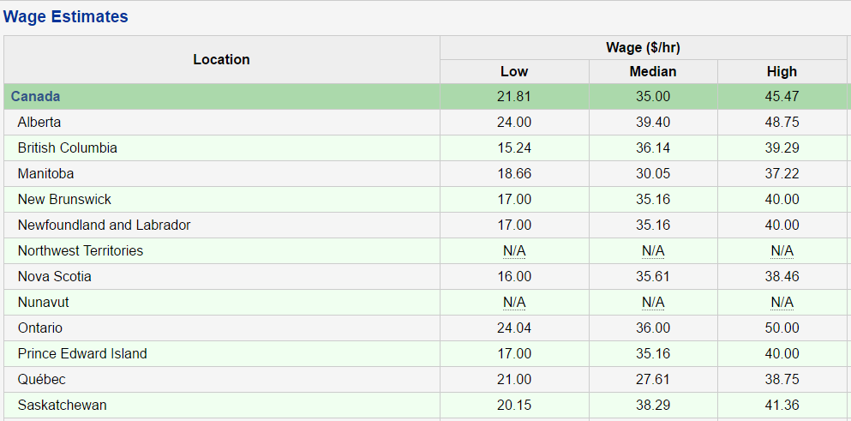
Source: [ Source: Labour Market Information - ESDC | Wage Methodology

Step two
Contact the regulatory body below for registration requirement. They will ask you to certify and translate documents if they are not in English or French. They will assess your educational transcripts against the education requirements in Canada. If they find you to be equal, they will allow you to register and allow you to take any necessary exams to become licensed.
If they do not find your education to be equal, they will tell you what classes are needed and you must then come to Canada as an international student to complete the requirements.
The regulatory board will also tell you what you may work as in the meantime you are either preparing for your licensing exam or bringing your schooling up to Canadian requirements.

Canadian Regulators of Dietitians
 | The College of Dietitians of British Columbia  Registrar: Fern Hubbard, BA, MEd  Suite 409, 1367 West Broadway  Vancouver, BC V6H 4A7  Phone: (604) 736-2016  Toll-Free: 1-877-736-2016  Fax: (604) 736-2018  Email: fhubbard@collegeofdietitiansbc.org  Website: www.collegeofdietitiansbc.org  College of Dietitians of Alberta  Doug Cook  Registrar & Executive Director  #740, 10707 - 100 Ave.  Edmonton, AB T5J 3M1  Phone: (780) 448-0059  Toll Free: 1-866-493-4348  Fax: (780) 489-7759  Email: registrar@collegeofdietitians.ab.ca  Website: www.collegeofdietitians.ab.ca  Saskatchewan Dietitians Association  Registrar, Lana Moore  #17-2010, 7th Ave.  Regina, SK S4R 1C2  Phone: (306) 359-3040  Fax: (306) 359-3046  Email: registrar@saskdietitians.org  Website: www.saskdietitians.org  College of Dietitians of Manitoba  Registrar, Michelle Hagglund  36 - 1313 Border Street  Winnipeg, MB R3H 0X4  Phone: (204) 694-0532  Fax: (204) 889-1755  E-mail: office.cdm@mts.net  Website: manitobadietitians.ca/home.aspx  College of Dietitians of Ontario  Registrar, Mary Lou Gignac  5775 Yonge Street  Suite 1810, Box 30  Toronto, ON M2M 4J1  Phone: (416) 598-1725  Fax: (416) 598-0274  E-mail: info@cdo.on.ca  Website: www.cdo.on.ca | Ordre professionnel des diététistes du Québec  Joanie Bouchard MSc(c) DtP  Professionnal Practice Coordinator  2155, rue Guy, bureau 1220  Montreal, QC H3H 2R9  Phone: (514) 393-3733  Fax: (514) 393-3582  E-mail: jbouchard@opdq.org  Web Site: www.opdq.org  New Brunswick Association of Dietitians  Pauline Watt  530 Main Street  Woodstock, NB E7M 2C3  Phone: (506) 324-9396  Fax: (506) 328-2686  Email: registrar@adnb-nbad.com  Website: www.adnb-nbad.com  Prince Edward Island  Dietitians Registration Board  Carolyn Knox, Registrar  PO Box 362 CTL  Charlottetown, PE C1A 7K7  Phone: (902) 892-9284  E-mail: registrar@peidietitians.ca  Website: www.peidietitians.ca  Nova Scotia Dietetic Association  Jennifer Garus, P. Dt.  NSDA Executive Manager  212 - 1496 Bedford Highway  Halifax, NS B4A 1E5  Phone: (902) 835-0253  Fax: (902) 835-0523  E-mail: nsda@ns.aliantzinc.ca  Website: www.nsdassoc.ca  Newfoundland & Labrador College of Dietitians  Cynthia Whalen, M.Sc., RD  Registrar (Acting) & Executive Coordinator  PO Box 1756  Postal Station C  St. John's, NL A1C 5P5  Phone: (709) 753-4040  Toll Free: 1-877-753-4040  E-mail: registrar@nlcd.ca  Website: www.nlcd.ca

Step Three
Start your processing for Immigration Visa with Immigration Canada. You can apply under one or more programs at the same time as long as you meet the requirements.
One of our newest Immigration stream for skilled workers and professional is the EXPRESS ENTRY program. You apply and enter into a pool of potential candidates from all over the world. You get points based on age, education and English/French capabilities. Immigration Canada holds monthly draws and gives the candidates with the highest score Permanent Residency with or without a job offer!

APPLY HERE: http://www.cic.gc.ca/ctc-vac/getting-started.asp
Answer a few questions to find out what immigration programs you can apply for. Each immigration program has different application and eligibility requirements. You will need about 10-15 minutes to complete the form.

You may be asked questions about your:
- Nationality –age -language ability -family members –education -work experience -income and/or net worth -details on any job offer
Based on your answers, they will tell you what programs you may be eligible for, so be as accurate as you can. If you are eligible, they will give you a detailed list of instructions on what to do next.

Step Four

Get your resume and cover letter ready. Please keep in mind that if your resume is able to get into the hands of a human resource hiring manager it has an average of 10 seconds to catch their attention.

Many hiring managers use recruitment software (ATS) applicant tracking system that uses specific keyword search on resumes and it determines if it gets passed on for review or straight into a rejection pile. First impressions, proper grammar/format and Canadian industry keywords are imperative in order to obtain an interview.

View our FREE easy to understand videos found on our website workincanadanow.ca. It provides detailed information for creating a winning Canadian style cover letter along with helpful tips to prepare for an interview.

If you prefer us to create a winning Canadian style resume and cover letter for you, we will be glad to assist and charge $49.99 Canadian dollars for this service.

Step five
Once you have your Canadian style cover letter and resume you can start applying for jobs. In Canada, we use the internet and LinkedIn for networking. Below you will find our most popular job boards but there are hundreds more that you can use.

Canadian Job Search Sites
Canadian Job Bank www.jobbank.gc.ca
Indeed www.indeed,ca
Monster Canada www.monster.ca

Step Six
Have any questions? Contact us we will be glad to help.

Visit our website workincanadanow.ca for all the latest tips and information on making your journey to Canada a smooth transition.

We also provide free city guides to help prepare you get acquainted to your new home before you arrive!

All the information you need to register your health card, obtain your social insurance number, find an apartment, get your drivers license and much more….

WE ARE HERE TO HELP AND WELCOME YOU TO CANADA

