WORK IN CANADA GUIDE
DENTAL HYGIENISTS
AND DENTAL THERAPISTS
NOC 3222
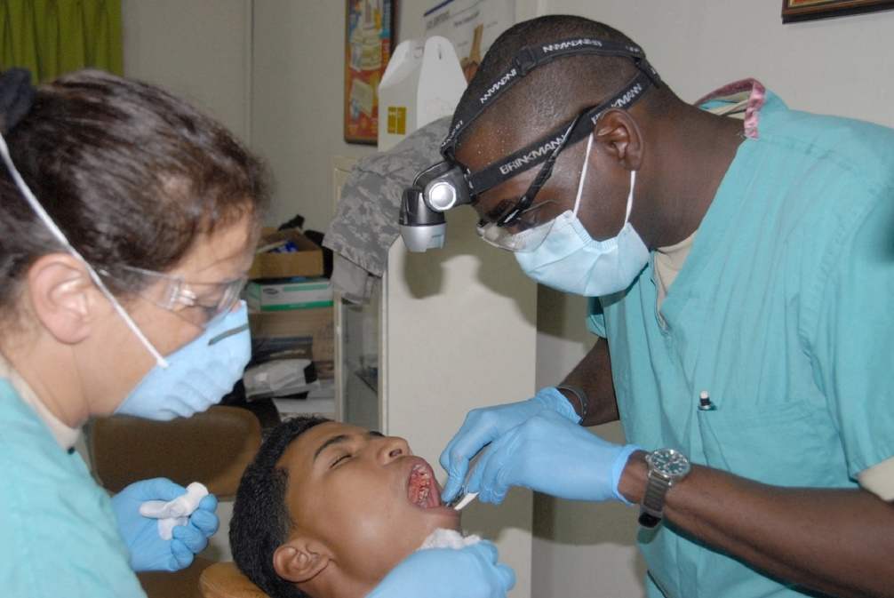
NOC 4152

Presented by:
WORK IN CANADA NOW consulting AND placement

DENTAL HYGIENISTS AND DENTAL THERAPISTS NOC 3222

In CANADA:
Dental hygienists provide dental hygiene treatment and information related to the prevention of diseases and disorders of the teeth and mouth. They are employed in dentists' offices, hospitals, clinics, educational institutions, government agencies and private industry. Dental therapists carry out limited dental services related to the prevention and treatment of diseases and disorders of the teeth and mouth. They are employed by the federal government and the provincial governments to provide services in rural and remote communities.
Job Titles
- dental hygienist
- dental nurse
- dental therapist
Job Duties
Dental hygienists perform some or all of the following duties:
- Conduct an initial dental assessment and consult with dentists on patient care
- Take dental impressions
- Instruct patients regarding oral hygiene procedures
- Clean and stimulate the gums to prevent gum disease
- Remove stains and deposits from teeth to prevent tooth and root decay
- Apply fluoride treatment
- Take and develop X-rays
- May perform restorative and orthodontic procedures under the direction of a dentist
- May supervise dental assistants in their health care functions

Dental therapists perform some or all of the following duties:
- Conduct dental assessments and consult with dentist on patient care
- Take dental impressions
- Take and develop X-rays
- Remove stains and deposits from teeth to prevent tooth and root decay
- Apply fluoride treatment
- Instruct patients regarding oral hygiene procedures
- Supervise dental assistants in their health care functions
- May drill and fill cavities, extract teeth and replace portions of tooth crown

Dental hygienists DENTAL NOC 3222

In Canada dental hygienists is a regulated profession and you must be licensed to practice with the regulatory body in the province you intend to live and work in.

Step One
Choose the province you intend to work in. If you already have friends or family in Canada it is best to start your new career in that province as you will already have a support system to help with your transition. Relocating to any new country can be challenging for a variety of reasons but can be well worth your time and efforts. If you don’t have a support system already in Canada I would recommend for you to choose a province that would fit your needs in terms of weather, population, available lifestyle activities and job opportunities.

Salary
Salary for dental hygienists in Canada vary by province and by employers. Below is a short summary of job postings and pay scale found on the Canadian Job Bank March 2017.
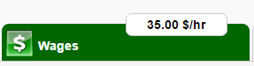

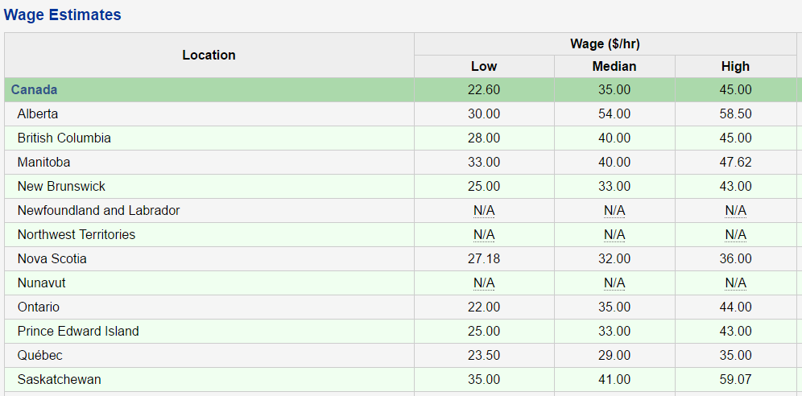
[ Source: Labour Market Information - ESDC | Wage Methodolog

Step two
Contact the regulatory body below for registration requirement. They will ask you to certify and translate documents if they are not in English or French. They will assess your educational transcripts against the education requirements in Canada. If they find you to be equal, they will allow you to register and take any necessary exams to license you.
If they do not find your education to be equal, they will tell you what classes are needed and you must then come to Canada as a student to complete the requirements.
The regulatory board will also tell you what you may work as in the meantime you are either preparing for your licensing exam or bringing your schooling up to Canadian requirements.

CDAC Commission on Dental Accreditation of Canada
www.cda-adc.ca

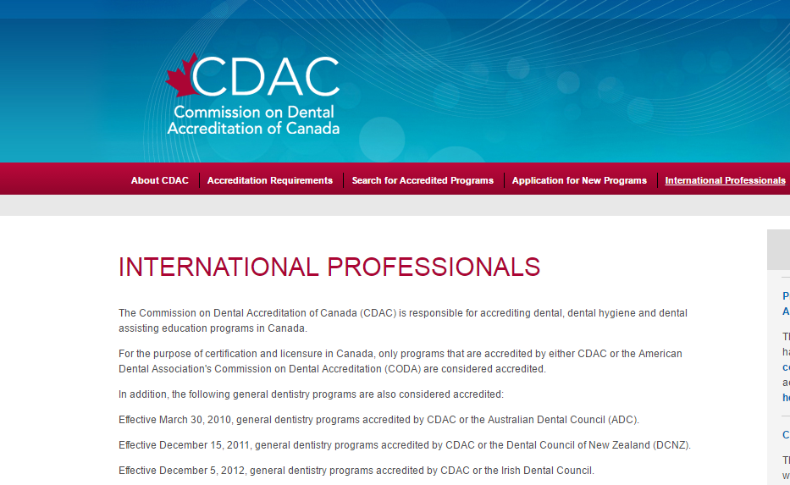

Step Three
Start your processing for Immigration Visa with Immigration Canada. You can apply under one or more programs at the same time as long as you meet the requirements. One of our newest Immigration stream for skilled workers and professional is the EXPRESS ENTRY program. You apply and enter into a pool of potential candidates from all over the world. You get points based on age, education and English/French capabilities. Employers’ from Canada with the approval to hire a foreign national must hire someone from this pool. Immigration Canada holds monthly draws and gives the candidates with the highest score Permanent Residency with or without a job offer!
APPLY HERE: http://www.cic.gc.ca/ctc-vac/getting-started.asp
Answer a few questions to find out what immigration programs you can apply for. Each immigration program has different application and eligibility requirements. You will need about 10-15 minutes to complete the form.
You may be asked questions about your:
Nationality –age -language ability -family members –education -work experience -income and/or net worth -details on any job offer
Based on your answers, they will tell you what programs you may be eligible for, so be as accurate as you can. If you are eligible, they will give you a detailed list of instructions on what to do next.

Step Four
Get your resume and cover letter ready. Please keep in mind that if your resume is able to get into the hands of a human resource hiring manager it has an average of 10 seconds to catch their attention.
Many hiring managers use recruitment software (ATS) applicant tracking system that uses specific keyword search on resumes and it determines if it gets passed on for review or straight into a rejection pile. First impressions, proper grammar/format and Canadian industry keywords are imperative in order to obtain an interview.
We offer a free service resume assessment and give you the recommendations on what to edit or add. Submit your resume to us through our website.
Download our free guide Find a Job in Canada found on our website workincanadanow.ca. It provides detailed information for creating a winning Canadian style cover letter and resume from the government of Alberta.

If you prefer us to create a winning Canadian style resume and cover letter for you, we will be glad to assist and charge $49.99 Canadian dollars for this service.

Step five
Once you have your Canadian style cover letter and resume you can start applying for jobs. In Canada we use the internet and LinkedIn for networking. Below you will find our most popular job boards but there are hundreds more that you can use.

Canadian Job Search Sites
Canadian Job Bank www.jobbank.gc.ca
Indeed www.indeed,ca
Monster Canada www.monster.ca

Step Six
Have any questions? Contact us we will be glad to help.
Visit our website workincanadanow.ca for all the latest tips and information on making your journey to Canada a smooth transition.
We also provide free city guides to help prepare you get acquainted to your new home before you arrive!
All the information you need to register your health card, obtain your social insurance number, find an apartment, get your drivers license and much more….

WE ARE HERE TO HELP AND WELCOME YOU TO CANADA

