WORK IN CANADA GUIDE
ELECTRICAL AND ELECTRONICS ENGINEERS
NOC 2133

NOC 4152

Presented by:
WORK IN CANADA NOW consulting AND placement

ELECTRICAL AND ELECTRONICS ENGINEERS NOC 2133

Electrical and electronics engineers design, plan, research, evaluate and test electrical and electronic equipment and systems. They are employed by electrical utilities, communications companies, manufacturers of electrical and electronic equipment, consulting firms, and by a wide range of manufacturing, processing and transportation industries and government.

In Canada computer and electrical and electronics engineers perform some or all of the following duties:
- Conduct research into the feasibility, design, operation and performance of electrical generation and distribution networks, electrical machinery and components and electronic communications, instrumentation and control systems, equipment, and components.
- Prepare material cost and timing estimates, reports and design specifications for electrical and electronic systems and equipment.
- Design electrical and electronic circuits, components, systems and equipment.
- Supervise and inspect the installation, modification, testing and operation of electrical and electronic systems and equipment.
- Develop maintenance and operating standards for electrical and electronic systems and equipment.
- Investigate electrical or electronic failures.
- Prepare contract documents and evaluate tenders for construction or maintenance.
- Supervise technicians, technologists, programmers, analysts and other engineers.

ELECTRICAL AND ELECTRONICS ENGINEERS NOC 2133
Electrical and electronics engineers is a regulated profession and you must be licensed to practice with the regulatory body in the province you intend to live and work in.

Salary
Salary for electrical and electronics engineer in Canada vary by province and by employers. Below is a short summary of job postings and pay scale found on the Canadian Job Bank March 2017.

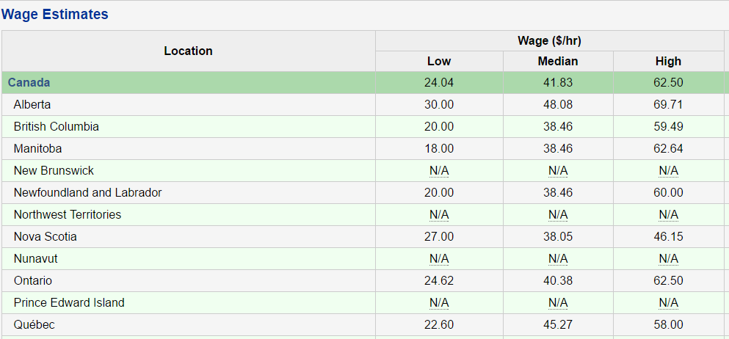

Step One
Choose the province you intend to work in. If you already have friends or family in Canada it is best to start your new career in that province as you will already have a support system to help with your transition. Relocating to any new country can be challenging for a variety of reasons but can be well worth your time and efforts. If you don’t have a support system already in Canada I would recommend for you to choose a province that would fit your needs in terms of weather, population, available lifestyle activities and job opportunities.

Step two
Contact the regulatory body below for registration requirement. They will ask you to certify and translate documents if they are not in English or French. They will assess your educational transcripts against the education requirements in Canada. If they find you to be equal, they will allow you to register and take any necessary exams to license you.
If they do not find your education to be equal, they will tell you what classes are needed and you must then come to Canada as an international student to complete the requirements.
The regulatory board will also tell you what you may work as in the meantime you are either preparing for your licensing exam or bringing your schooling up to Canadian requirements.

Engineer Regulatory Body

engineerscanada.ca
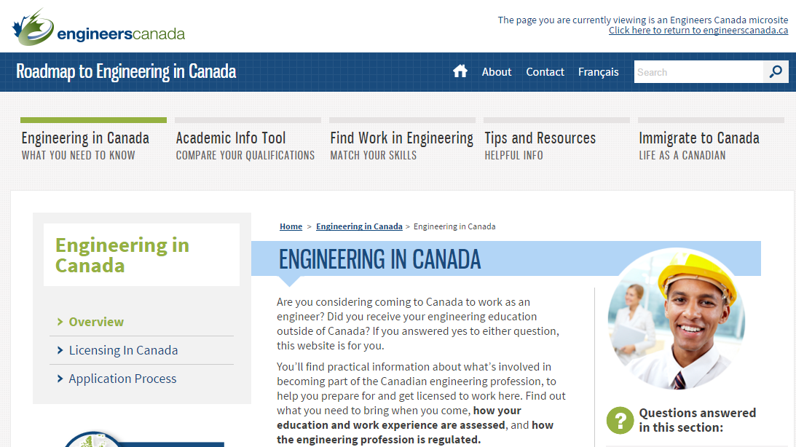

Step Three
Start your processing for Immigration Visa with Immigration Canada. You can apply under one or more programs at the same time as long as you meet the requirements. One of our newest Immigration stream for skilled workers and professional is the EXPRESS ENTRY program. You apply and enter into a pool of potential candidates from all over the world. You get points based on age, education and English/French capabilities. Employers’ from Canada with the approval to hire a foreign national must hire someone from this pool. Immigration Canada holds monthly draws and gives the candidates with the highest score Permanent Residency with or without a job offer!
APPLY HERE: http://www.cic.gc.ca/ctc-vac/getting-started.asp
Answer a few questions to find out what immigration programs you can apply for. Each immigration program has different application and eligibility requirements. You will need about 10-15 minutes to complete the form.
You may be asked questions about your:
Nationality –age -language ability -family members –education -work experience -income and/or net worth -details on any job offer
Based on your answers, they will tell you what programs you may be eligible for, so be as accurate as you can. If you are eligible, they will give you a detailed list of instructions on what to do next.

Step Four
Get your resume and cover letter ready. Please keep in mind that if your resume is able to get into the hands of a human resource hiring manager it has an average of 10 seconds to catch their attention.
Many hiring managers use recruitment software (ATS) applicant tracking system that uses specific keyword search on resumes and it determines if it gets passed on for review or straight into a rejection pile. First impressions, proper grammar/format and Canadian industry keywords are imperative in order to obtain an interview.
We offer a free service resume assessment and give you the recommendations on what to edit or add. Submit your resume to us through our website.
Download our free guide Find a Job in Canada found on our website workincanadanow.ca. It provides detailed information for creating a winning Canadian style cover letter and resume from the government of Alberta.

We offer to create you a professional Canadian style resume and cover letter for a fee of $49.99 Canadian dollars.

Step five
Once you have your Canadian style cover letter and resume you can start applying for jobs. In Canada we use the internet and LinkedIn for networking. Below you will find our most popular job boards but there are hundreds more that you can use.

Canadian Job Search Sites
Canadian Job Bank www.jobbank.gc.ca
Indeed www.indeed,ca
Monster Canada www.monster.ca

Step Six
Have any questions? Contact us we will be glad to help.
Visit our website workincanadanow.ca for all the latest tips and information on making your journey to Canada a smooth transition.
We also provide free city guides to help prepare you get acquainted to your new home before you arrive!
All the information you need to register your health card, obtain your social insurance number, find an apartment, get your drivers license and much more….

WE ARE HERE TO HELP AND WELCOME YOU TO CANADA

