WORK IN CANADA GUIDE
GEOLOGICAL AND MINERAL TECHNOLOGISTS AND TECHNICIANS
NOC 2212
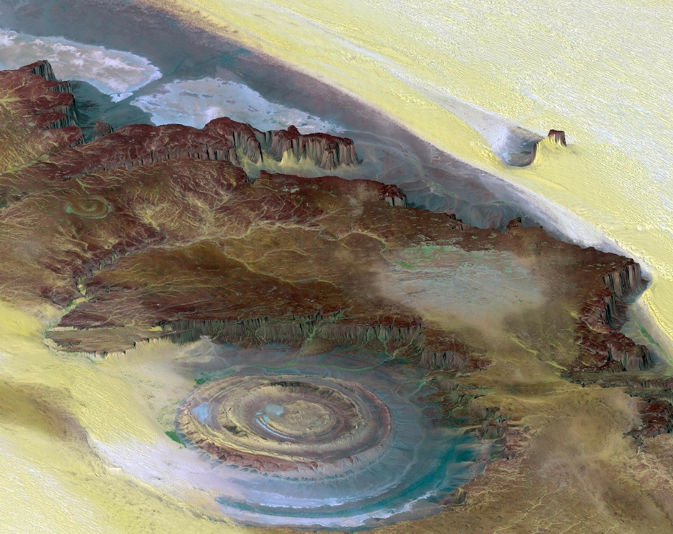

Presented by:
WORK IN CANADA NOW consulting AND placement

GEOLOGICAL AND MINERAL TECHNOLOGISTS AND TECHNICIANS

NOC 2212

In CANADA:
Geological and mineral technologists and technicians provide technical support and services or may work independently in the fields of oil and gas exploration and production, geophysics, petroleum engineering, geology, mining and mining engineering, mineralogy, extractive and physical metallurgy, metallurgical engineering and environmental protection. They are employed by petroleum and mining companies, consulting geology and engineering firms, and by governments and educational institutions as well as by a variety of manufacturing, construction and utilities companies.

Included Job Titles
geological technician, groundwater technologist, log technician, marine geoscience technologist, metallurgical technologist, mineralogy technician, mining engineering technologist, mining technologist, petrology technician, reservoir engineering technician, rock mechanics technician, welding technologist, geophysical technologist, petroleum engineering technologist, petroleum technician, seismic technician, assayer.

Job Duties
Geological and mineral technologists perform some or all of the following duties:
- Conduct or direct geological, geophysical, geochemical, hydrographic or oceanographic surveys, prospecting field trips, exploratory drilling, well logging or underground mine survey programs
- Configure, operate and maintain geophysical survey and well logging instruments and equipment
- Prepare notes, sketches, geological maps and cross sections
- Prepare, transcribe or analyze seismic, gravimetric, well log or other geophysical and survey data
- Assist engineers and geologists in the evaluation and analysis of petroleum and mineral reservoirs
- Prepare or supervise the preparation of rock, mineral or metal samples and perform physical and chemical laboratory tests
- Conduct or assist in environmental audits, in the design of measures to minimize undesirable environmental effects of new or expanded mining and oil and gas operations, and in the development of waste management and other related environmental protection procedures
- May supervise oil and gas drilling, well completions and work-overs.

GEOLOGICAL AND MINERAL TECHNOLOGISTS AND TECHNICIANS NOC 2212
GEOLOGICAL AND MINERAL TECHNOLOGISTS AND TECHNICIANS in Canada is a regulated profession and you must be licensed to practice with the regulatory body in the province you intend to live and work in.

Step One
Choose the province you intend to work in. If you already have friends or family in Canada it is best to start your new career in that province as you will already have a support system to help with your transition. Relocating to any new country can be challenging for a variety of reasons but can be well worth your time and efforts. If you don’t have a support system already in Canada I would recommend for you to choose a province that would fit your needs in terms of weather, population, available lifestyle activities and job opportunities. I have made easy to follow city guides and videos to help you learn about our many cities and provinces. Please go to CITY GUIDES located on our website www.workincanadanow.ca

Salary
GEOLOGICAL AND MINERAL TECHNOLOGISTS AND TECHNICIANS in Canada vary by province and by employers. Below is a short summary of a pay scale found on the Canadian Job Bank MARCH 2017.
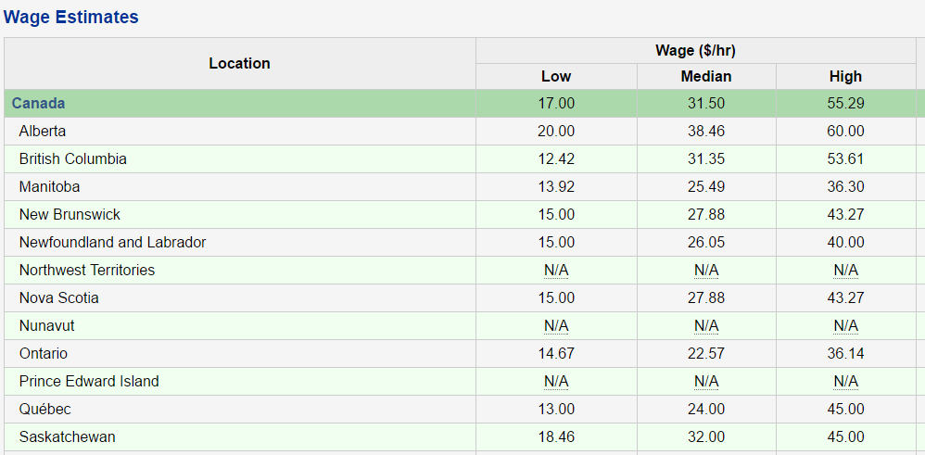
Source: [ Source: Labour Market Information - ESDC | Wage Methodology

Step two
Contact the regulatory body below for registration requirement. They will ask you to certify and translate documents if they are not in English or French. They will assess your educational transcripts against the education requirements in Canada. If they find you to be equal, they will allow you to register and allow you to take any necessary exams to become licensed.
If they do not find your education to be equal, they will tell you what classes are needed and you must then come to Canada as an international student to complete the requirements.
The regulatory board will also tell you what you may work as in the meantime you are either preparing for your licensing exam or bringing your schooling up to Canadian requirements.

https://geoscientistscanada.ca
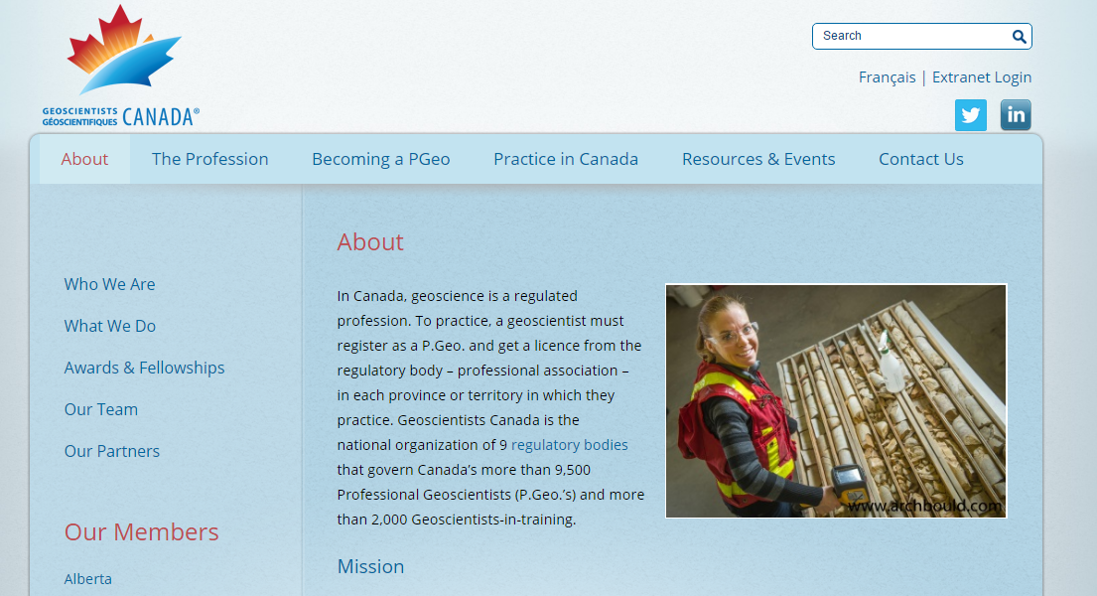

Step Three
Start your processing for Immigration Visa with Immigration Canada. You can apply under one or more programs at the same time as long as you meet the requirements.
One of our newest Immigration stream for skilled workers and professional is the EXPRESS ENTRY program. You apply and enter into a pool of potential candidates from all over the world. You get points based on age, education and English/French capabilities. Immigration Canada holds monthly draws and gives the candidates with the highest score Permanent Residency with or without a job offer!

APPLY HERE: http://www.cic.gc.ca/ctc-vac/getting-started.asp
Answer a few questions to find out what immigration programs you can apply for. Each immigration program has different application and eligibility requirements. You will need about 10-15 minutes to complete the form.

You may be asked questions about your:
- Nationality –age -language ability -family members –education -work experience -income and/or net worth -details on any job offer
Based on your answers, they will tell you what programs you may be eligible for, so be as accurate as you can. If you are eligible, they will give you a detailed list of instructions on what to do next.

Step Four

Get your resume and cover letter ready. Please keep in mind that if your resume is able to get into the hands of a human resource hiring manager it has an average of 10 seconds to catch their attention.

Many hiring managers use recruitment software (ATS) applicant tracking system that uses specific keyword search on resumes and it determines if it gets passed on for review or straight into a rejection pile. First impressions, proper grammar/format and Canadian industry keywords are imperative in order to obtain an interview.

View our FREE easy to understand videos found on our website workincanadanow.ca. It provides detailed information for creating a winning Canadian style cover letter along with helpful tips to prepare for an interview.

If you prefer us to create a winning Canadian style resume and cover letter for you, we will be glad to assist and charge $49.99 Canadian dollars for this service.

Step five
Once you have your Canadian style cover letter and resume you can start applying for jobs. In Canada, we use the internet and LinkedIn for networking. Below you will find our most popular job boards but there are hundreds more that you can use.

Canadian Job Search Sites
Canadian Job Bank www.jobbank.gc.ca
Indeed www.indeed,ca
Monster Canada www.monster.ca

Step Six
Have any questions? Contact us we will be glad to help.

Visit our website workincanadanow.ca for all the latest tips and information on making your journey to Canada a smooth transition.

We also provide free city guides to help prepare you get acquainted to your new home before you arrive!

All the information you need to register your health card, obtain your social insurance number, find an apartment, get your drivers license and much more….

WE ARE HERE TO HELP AND WELCOME YOU TO CANADA

